Low Level Design (LLD) & Technical Specification

1. Low Level Design
Component | Responsibility
Frontend | UI, uploads, sharing, search
Auth Service | Login, tokens, RBAC
File Service | Upload/download/versioning
Sharing Service | Links & permissions
Search Service | Indexing & search
Audit Service | Logs & reports
Storage | Object storage for files
Database | Metadata storage

2. API List
Method | Endpoint | Purpose
POST | /auth/login | Login
GET | /users | List users
POST | /files | Upload file
GET | /files/{id} | Download file
PUT | /files/{id} | Update metadata
POST | /shares | Create share
GET | /search?q= | Search
GET | /versions/{fileId} | Versions
POST | /comments | Add comment
GET | /audit | Audit logs

3. Architecture Diagram
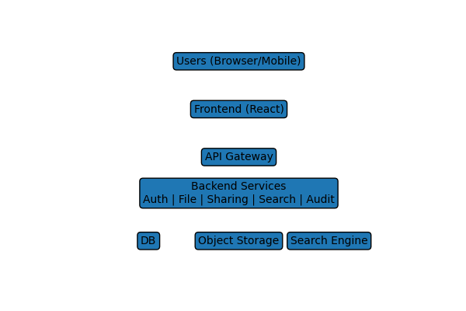

4. ER Diagram
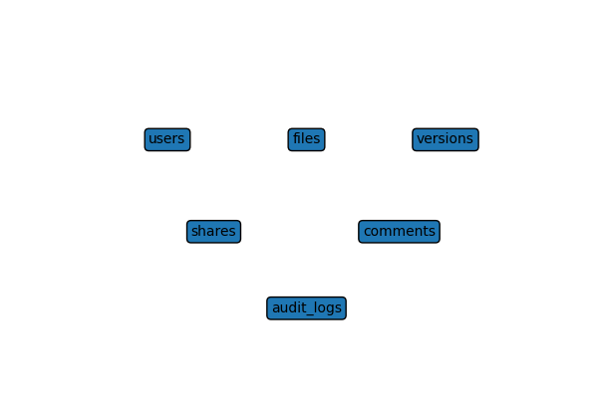

5. Tech Stack Recommendation
Layer | Recommended Tech
Frontend | React + TypeScript
Backend | Node.js (NestJS/Express)
Database | PostgreSQL
Storage | AWS S3
Search | Elasticsearch/OpenSearch
Auth | OAuth2 / Keycloak
Cache | Redis
Deployment | Docker + Kubernetes

6. Deployment Plan
Step | Description
CI/CD | GitHub Actions build & test
Containerization | Docker images
Registry | Push to ECR/ACR
Kubernetes | Deploy services
Storage | S3 bucket setup
Monitoring | Prometheus + Grafana
Backup | Daily DB snapshots
Scaling | HPA enabled

